**Underwater Boat Camera Rig Design Report**

**Project Title:** Design and development of an underwater Boat Camera Rig

**Author:** Mpilonhle Sinethemba Zondi

# Executive Summary

This report outlines the design and the development of an underwater boat camera rig intended for marine research and underwater photography. The camera rig is designed to capture high quality underwater image and footage for scientific purposes. The key elements of the design include mounting and stabilization, waterproof housing and cable management. EURO STEEL

# Introduction

The undersea world continues to be a source of fascination and investigation. To facilitate better understanding and documentation of this environment, this project aims to design a robust camera rig that can be mounted on a *Catarob* for underwater photography and research.

# Objectives

* Design and underwater camera rig suitable for attachment to a *Catarob.*
* Capture high- resolution underwater images and footage.
* Ensure the rig’s stability and should be detachable.
* Capable of operating at depth of up to 1 meter.

# Methodology

1. Research: Extensive research on materials used in marine applications, rigid detachable mountings, and waterproof housing.
2. Design: Creation of 3 concept designs and based on the requirements and the supervisor advice, a final design is chosen.
3. Component Selection: Selection of the appropriate camera, material for the rig, and the type of mounting.
4. Prototype Development: Detailed CAD design to be sent to the workshop.

# Requirements

* Suspended under water at a fixed height.
* Strong and rigid structure that is easily manufacturable.
* Easily deployable.
* Waterproof housing for the camera and the pressure sensor.
* Lighting system to clear under water illumination.

# Design specification

This section presents the 3 structural concepts for the underwater camera rig.

## Design concepts

### Design Concept 1

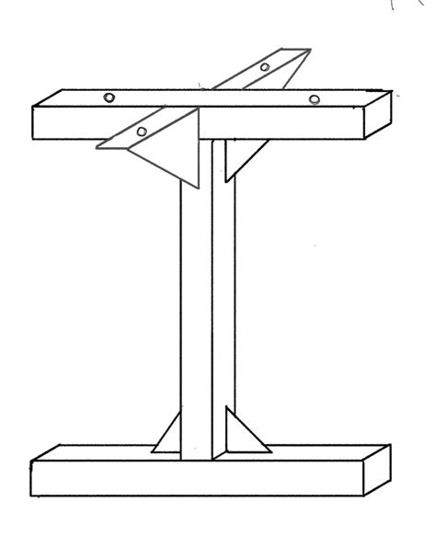

Gussets

Figure 1: Concept 1

I shaped structure that is fairly easily manufacturable. Made up of 3 hollow metal bars that are welded together. Triangular gussets are added to transfer stresses between connected members and help strengthen the joint between them. Two corner triangular gussets are added for structural rigidity and for mounting purposes.

### Design concept 2

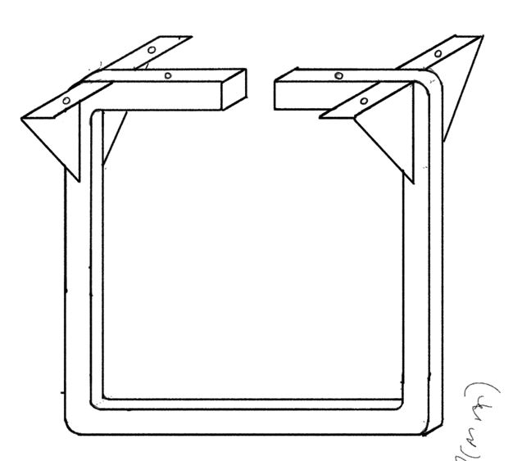

Figure 2: Concept 2

Square loop shaped structure with an opening at the top for manufacturability purposes i.e so that the metal can be easily bent to the desired shaped. The structure is fairly simple with four corner triangular gussets to ensure stability and minimise vibrations during operation. Aluminum can be used since it is lightweight, strong and corrosion-resistant but also stainless can be used since it is strong and extremely corrosion resistant. (Steal is heavier than aluminium).

### Design Concept 3

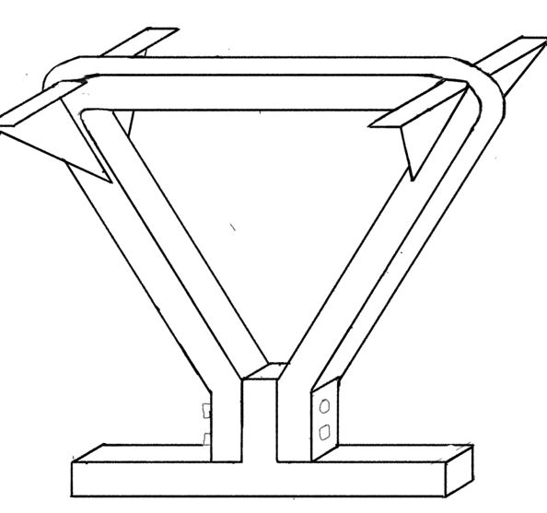

Figure 3: Concept 3

Triangular shaped structure with a removable bar at the bottom that is fasten with bolts and nuts. Also comprises of Gussets for mounting supports.

## Material selection

For the overall structure of the rig, there are two material options. The materials were chosen for their durability and resistance to corrosion in saltwater environments. The main frame can be made from solid or hollow tubes. Extrusions are also a valid option.

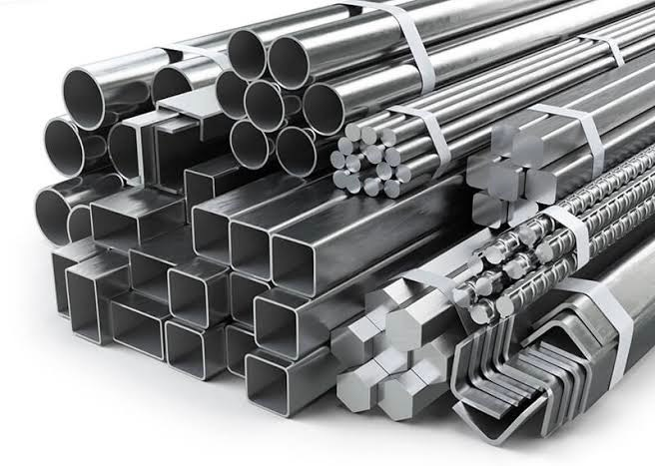

Figure 4: Stainless steel 316L

### Aluminum

Aluminum is significantly lighter than stainless steel which means that it will not overload the *Catarob.* Aluminum can withstand the corrosive effects of saltwater, especially when properly treated or coated. Aluminum is generally not as strong as stainless steel but since the rig will be at a depth of not more than 1m meter, aluminium should be suitable for this application.

### Stainless steel

Stainless steel is highly corrosion resistant, making it excellent for extended underwater use in saltwater environments. Stainless steel is highly durable and can withstand rough underwater conditions. It is much heavier than aluminium and also costs more, both in terms of material and machining.

(Stainless steel 316L)

Consideration: Weight vs Cost

### Mounting and Stabilization

The rig is mounted on the *Catarob* using stainless steel bolts and nuts to ensure stability and minimise vibrations during operation. Their design makes them easy to assemble and disassemble, with little to no effort. Moreover, they are cost efficient. Size size size

## Overall dimensions

The rig’s minimum height should be approximately 45cm to ensure that the cameras are positioned below the hulls, allowing for unobstructed capture of clear images. The width of the rig is constrained by the dimensions of the central bridge and the presence of the electronics box on the bridge. The maximum width is about 35 cm.

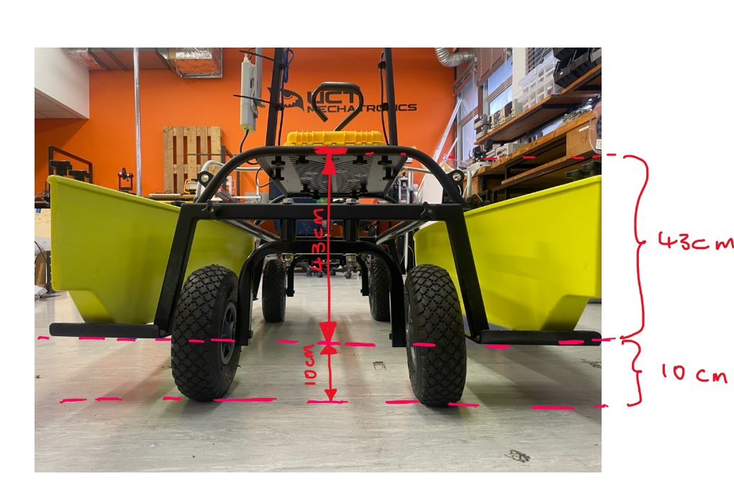

Figure : Rear view of the Catarob

The mounting of the rig presents a challenge due to the presence of cut-out sections in the central bridge plate (see figure below). As a result, fasteners should be placed along the central plane and edges in the solid sections.

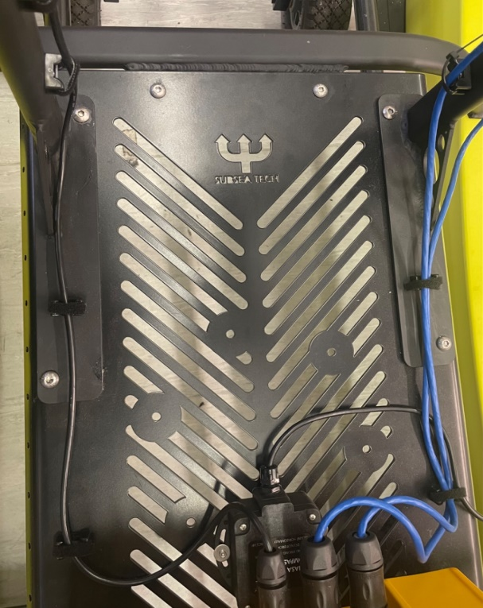

~ 35 cm

Figure : Central bridge plate with cut-out sections